Europass  Curriculum Vitae |  | 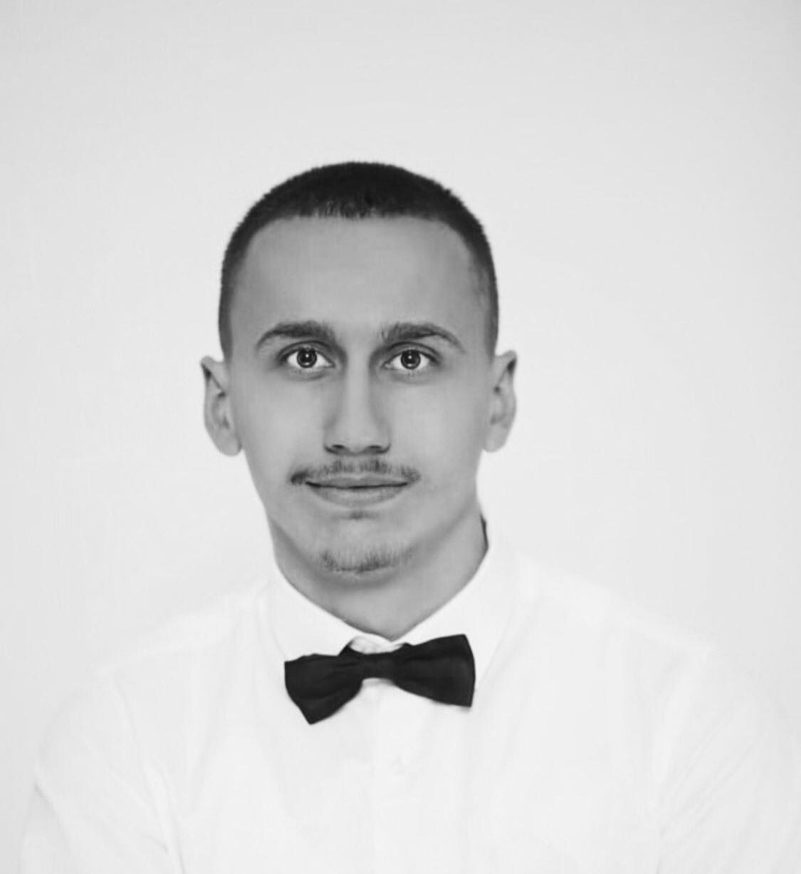
Personal information
First name(s) / Surname(s) |  | Ilir Misini
Address(es) |  | 24 Marsi,Dardania 2,Gjilan,Kosove.
Telephone(s) |  | 048 559 045
Fax(es)
E-mail |  | iilirmisini4@gmail.com , ilirmisini2004@gmail.com
Nationality |  | Albanian
Date of birth |  | 21.06.2004
Gender |  | Male
Desired employment / Occupational field |  | IT,(Network Enginner,CCNA,CCNP,CCIE),Cybersecurity.
Work experience |  | …………..
Dates |  | ……………
Occupation or position held |  | ……………
Main activities and responsibilities |  | …………….
Name and address of employer |  | …………….
Type of business or sector |  | …………….
Education and training |  | Bachelor of Computer Science Engineering, and i have a certificate in CCNA and IT TECHNICIAN,NETWORK ADMINISTRATOR certificate.
Dates |  | 2022-25
Title of qualification awarded |  | BACHELOR OF COMPUTER SCIENCE ENGINEERING
Principal subjects/occupational skills covered |  | (Java programming basic and oriented based in objects),PYTHON,HTML,CSS,JAVA SCRIPT and PHP.
Name and type of organisation providing education and training |  | UBT Prishtine,Kosove
Level in national or international classification |  | CCNA CERTIFICATION,IT TECHNICIAN,NETWORK ADMINISTRATOR.
Personal skills and competences |  | Critical-thinking , problem-solving,strong communication, leadership,time management,creativity,teamwork
Mother tongue(s) |  | Albania Language,English
Other language(s) |  | Specify language and evidence of skill level (language certificate)
Self-assessment |  |  | Understanding |  |  |  |  | Speaking |  |  |  |  | Writing
European level |  |  | Listening |  | Reading |  |  | Spoken interaction |  | Spoken production
Albanian |  |  |  | C2 |  | C2 |  |  | C2 |  |  | C2 |  | C2
English |  |  |  | B1 |  | B2 |  |  | B2 |  |  | B2 |  | B2
Social skills and competences |  | I have done many meetings in the IT field, AI development, and network field. I am a communicative person with others and clients.
Organisational skills and competences |  | I’m motivated to always be with a great team to cooperate with others team or clients.
Technical skills and competences |  | Technical Writing,Coding,Network Configuration,Hardware Deployment,Operating System knowledge.
Computer skills and competences |  | JAVA,PYTHON,NETWORKING,IT,HTML,CSS
Artistic skills and competences |  | …..
Other skills and competences |  | 2D,3D,  Marketing video creator,  Virtual Tour 360° creator,  Internet of Things (IoT),
Driving licence |  | B
Additional information |  | I completed a 3D project for UBT College, which was presented at an international conference in Greece by the Dean of Computer Science and Engineering.
Annexes |  | …..

